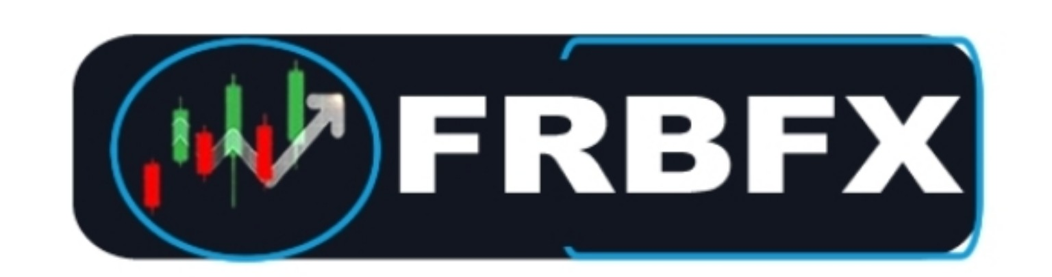 | FIRSTRATEBITFX  Private Investment Company  Compliance & Verification Information

FirstratebitFX is a private investment company. Private investment companies are not always required to register with the SEC or become FINRA members because U.S. securities laws distinguish between public offerings and private offerings. Many private firms operate under exemptions from registration while remaining subject to applicable U.S. securities laws.
While a private investment company may qualify for exemptions from SEC registration, it remains subject to applicable federal and state securities laws, including anti-fraud provisions and other legal and regulatory requirements. Registration exemptions do not exempt a company from complying with these laws.
Although a private company may not have an SEC registration number or FINRA membership, it is still expected to comply with applicable legal requirements, including federal and state anti-fraud laws, accurate recordkeeping, AML/KYC obligations where applicable, truthful disclosures, honoring investor agreements, and maintaining appropriate compliance and risk management practices.
Our compliance and risk management functions are overseen by Aisha Johnson, Chief Risk Officer, whose background includes service as a former SEC regulator. Her role is to oversee compliance, regulatory standards, and risk management, helping ensure the company operates in accordance with applicable legal and compliance requirements.
FirstratebitFX is committed to maintaining high standards of compliance, transparency, and client service. To the best of our knowledge, we are not aware of any regulatory findings or enforcement actions against the company.
To the best of our knowledge, FirstratebitFX has not been the subject of any SEC or FINRA enforcement action or finding of fraud.

